Number: 002-E  Status: 11/18  Work Area: Institute for Biochemistry |  |  | Operating Instruction  according to Ordinance on Hazardous Substances |  |  | 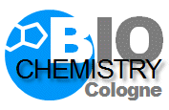  Universität zu Köln
1. NAME OF HAZARDOUS SUBSTANCE
40% Acrylamide-solution
2. HAZARDS FOR HUMAN AND ENVIRONMENT
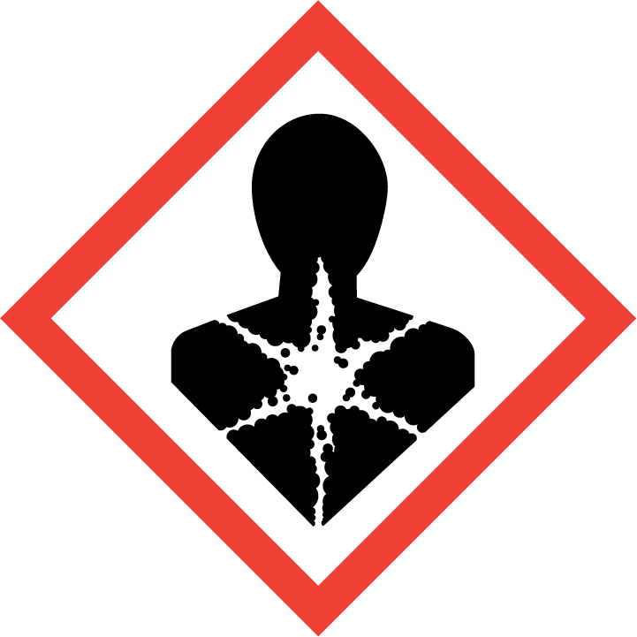  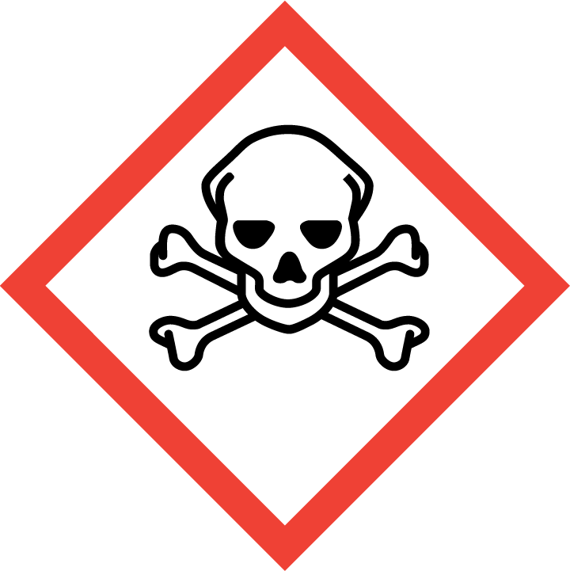  GEFAHR |  | CMR-substance:  May cause cancer. (H350)  May cause genetic defects. (H340)  Probably affect fertility. (H361f)  Toxic if swallowed. (H301)  Harmful by skin contact or inhalation. (H312 + H332)  Damages organs during prolonged or repeated exposure. (H372)  Causes severe eye irritation. (H319)  Causes skin irritation. (H315)  May cause allergic skin reactions. (H317)  Polymerized under intense heat generation at elevated temperatures and in contact with polymerization initiators (e.g. UV light, oxidizing agents, acids, alkalis). There is a risk of explosion in the event of uncontrolled reaction.  WHC: 3 (severely hazardous to waters)
3. PROTECTIVE MEASURES AND RULES OF CONDUCT
Only work in the fume hood and keep the front screen closed.
Polymerized acrylamide still contains monomer residues dissolved in aqueous solution.
Keep reactive substances away or only add them in a controlled manner.
Avoid inhalation of vapours and aerosols! (P261)
Wear generally prescribed protective equipment/protective clothing.
Wear suitable gloves (e.g. nitrile disposable gloves).
Keep under lock and key or accessible only to competent and reliable personnel.
No employment for pregnant women and nursing mothers.
4. BEHAVIOR IN CASE OF DANGER
Clear and secure the hazard area, inform supervisor.
Always wear protective goggles and suitable gloves when wiping up spilled substance.
Absorb spilled acrylamide with damp cloths and dispose of in "operating materials contaminated with chemicals”.
Prevent penetration into soil, water and sewers!
5. FIRST AID |  |  |  |  | Emergency: 01-112
  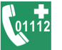 | Observe self-protection.  After eye contact: immediately rinse extensively (at least 10 min) with opened eyelids with water, protecting the uninjured eye.  After skin contact: remove contaminated clothing and underwear/shoes immediately. Rinse skin with plenty of water.  Afer swallowing: immediately rins the mouth thoroughly. Drink water in small sips.
6. PROPER DISPOSAL
Do not pour into sink!
Dispose of material, of contaminated absorbent material and cleaning cloths, packaging with residual contents for disposal in „operating amterials contaminated with chemicals“. Dispose of acrylamide-containing solutions in canisters “toxic aquaeous solutions“
 |  |  |  | Signature Executive Director of Institute for Biochemistry

